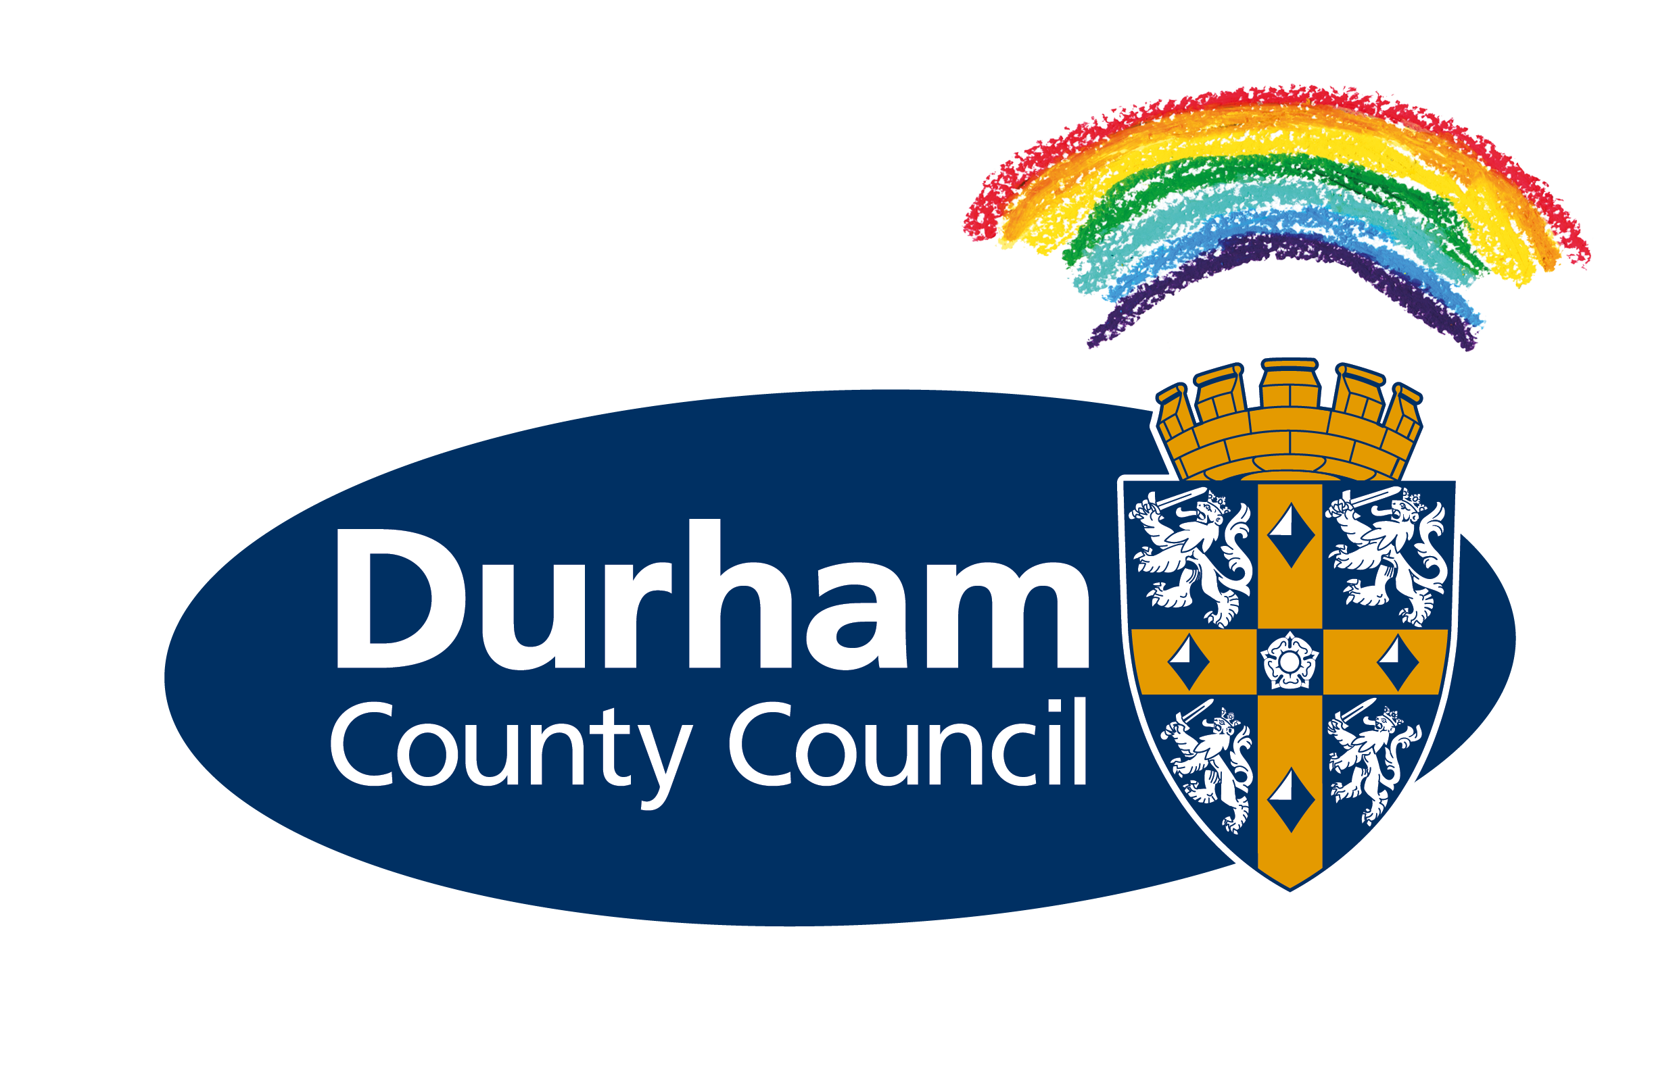
Press Release

Date: | Friday 7 January 2022
email: | PressTeam@durham.gov.uk

Council seeks views on what library services people want for themselves, their family and their community

Residents across County Durham can have their say on the future of local library services.

Durham County Council held the last review of the county’s library service in 2012. In recent years society has experienced massive digital and technological advancements and as a result, services have needed to be revitalised to reflect this.

The council now needs the public’s help to continually keep up to date and make sure library services are fit for purpose, continue to provide the best experience, and also attract new users. The consultation is part of a broader commitment by the council to providing robust local services.

As part of the latest review, the authority wants to gather views and opinions to help it understand what library users value about the services they use, why some people don’t use the library and what County Durham residents would like the service to be like in the future.

This will help the council to:
• Identify new priorities and needs for library services for all County Durham residents
• Understand the role of the library within the community
• Support community needs and aspirations
• Ensure it continues to provide a comprehensive, engaged, responsive and efficient service
• Create a better link between libraries and the way communities access wider services, with a focus on usage and convenience
• Identify and recommend the use of new technologies in the library service.

Whether people regularly visit their local branch, access digital library services or currently don’t use the library service, the council wants to hear from everyone on how services should be delivered in the future.

Continues…

The consultation is about understanding the needs of the community the service provides for and how things might be improved.

Libraries continue to be a vital community asset, with 39 libraries throughout County Durham, 12 of which are town centre-based and 27 which are smaller community-based sites, playing a key role in neighbourhoods and communities.

During the pandemic County Durham’s libraries have played a vital role in supporting communities, with the introduction of a ‘pick and collect’ service which enabled people to borrow books during lockdown. The council also runs a mobile library vehicle, outreach services to people who are housebound and a book-bus to care homes.

Cllr Elizabeth Scott, the council’s Cabinet member for economy and partnerships, said: “We are aware of the vital role that libraries play in all of our communities in County Durham which is why it is important that we undertake this engagement with the public to make sure we are providing the best service possible.

“Literature and libraries are an integral part of our cultural identity and this is something that we are keen to promote in the county’s bid to be named UK City of Culture 2025.

“This is about listening and understanding local needs, as well as making sure that library services cater for all residents, young and old, both now and in the future, so please take part and give us your views.”

The council will be contacting all library users directly by email to inform them of the work to review the current service, and to encourage completion of the online or paper survey, as well as hosting a number of focus groups whereby people will be able to directly get involved and have their say as part of the consultation.

People will also be encouraged to attend their local Area Action Partnership (AAP) meeting where the review will be discussed. The work will be delivered with Counterculture, which helps cultural, educational, and creative organisations to plan, manage and thrive.

Members of the public can have their say by going to www.durham.gov.uk/consultation to complete an online survey or register to attend a public event. Alternatively, people can pick up a paper survey from local libraries.

The deadline for comments is 5pm on Friday 1 April 2022.

For more details about the consultation, including information on next steps and FAQs, go to www.durham.gov.uk/consultation

ENDS

Notes to editors

Please see attached image of a woman reading from a library book.

