Become a Public Representative you looking for a new volunteering challenge this year? Would you like to help the Derwent Valley Partnership (DVP) identify local issues, develop projects to help tackle these and have a say in where our funding is spent? for the Derwent Valley Area Action Partnership!
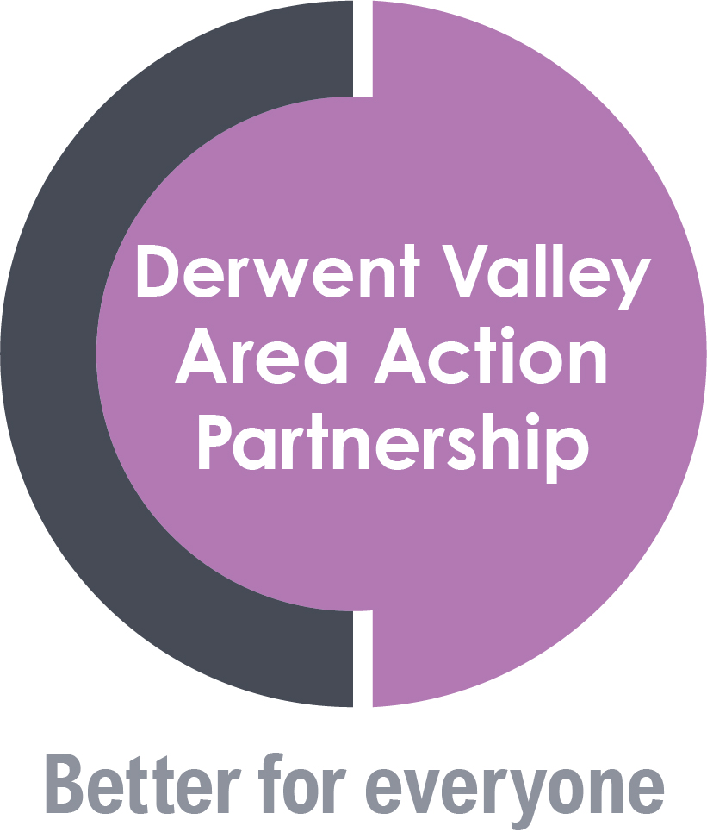
Business Representative Wanted!

Do you have knowledge of local business issues in the Consett and surrounding areas, and have some time to spare to be involved in local decision making in the area?

If the answer is yes, the Derwent Valley Partnership currently has a business representative vacancy on its Board and would love to hear from you.

As one of our partner representatives (representing the local business community alongside health, housing, fire and rescue, police, voluntary and community sector and the Council), you would be required to attend six pre-scheduled Board meetings per year in a voluntary capacity.
The role is about sharing valuable knowledge and being passionate about local business and the wider community – helping to make a difference in our area.

To find out more about the role and/or to register your interest, please contact the Derwent Valley Partnership Team at dvaap@durham.gov.uk or telephone us on 07818 510365
re

.
2023

