

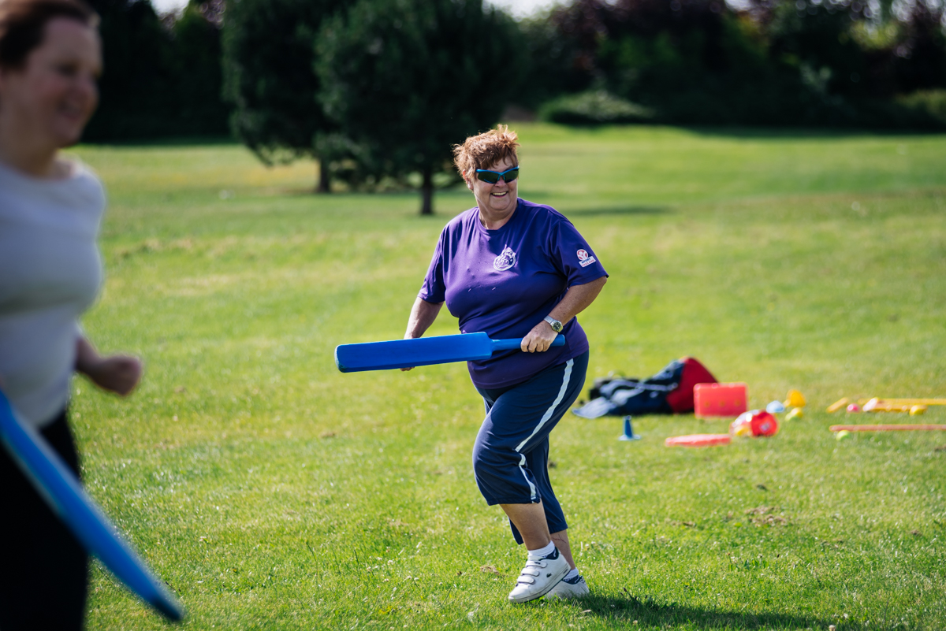

­

Chair Recruitment Pack



Chair Recruitment Pack

**Your Application**

Thank you for your interest in this post. On the following pages, you will find details of the role and the selection process to assist you in completing and tailoring your application.

In order to apply you should submit:

* An up-to-date CV which shows your full career history – we recommend that this is no longer than three pages and includes two referees who can be contacted prior to interview;
* A supporting statement explaining why you are interested in this role, detailing how you are a good candidate for this post and how you fulfil the role profile and person specification – we recommend that this is no longer than three pages;
* The declaration form – completion of the equalities section is not mandatory, this is requested for monitoring purposes in line with our commitment to equality and diversity.

Please indicate on the declaration form if you cannot attend any of the interview dates.

Please note that applications can only be considered if all the documentation is complete. Please submit your completed application documents FAO Beth Donkin to [hello@countydurhamsport.com](mailto:hello@countydurhamsport.com)

**Timeline**

Applications must be received by midnight Wednesday 30 March 2022.

Invitations to interview will be made during the week of 11 April 2022.

Interviews will be held on Thursday 28 April 2022 in person (unless circumstances do not allow).

………………………………………………………………………………………………………………………………………………………………………

Beth Donkin

Office Manager

beth.donkin@countydurhamsport.com

**Welcome Note**

Thank you for your interest in County Durham Sport.

We are delighted you are interested in this exciting post to drive the Active Partnership forward and fulfil our vision and mission. County Durham Sport (CDS) is one of 43 Sport England funded Active Partnerships. In County Durham, CDS operates as an independent company, with charitable status. Our role is to support, influence and improve the local delivery system for sport and physical activity and remove the barriers to moving. Ultimately, tackling inequalities is at the core of our work, we influence the system to ensure those people not currently accessing/benefitting from physical activity can get involved.

CDS has a passionate belief that everyone is able to improve the quality of their life through involvement in sport and physical activity. Our partnership’s ambition is to inspire and connect people and organisations to raise aspiration and remove the barriers to an active and healthy lifestyle and encourage our local system to reflect the needs, aspirations and requirements of the people and communities we serve.

The Chair leads the Board and holds the team to account for performance against strategic objectives. As such, we are looking for a collaborative leader who understands both the benefits of physical activity and its contribution to improving health, social and economic outcomes. The Chair will also understand the key role the Active Partnership can play in improving the local system (in line with our strategy) and will build upon, and advance, the excellent relationships we currently have with our public sector partners in Health, Durham County Council, Education and schools as well as with our partners in the University, community and third sectors.

Working with the Managing Director, the Chair will also have strategic oversight of the organisation: ensuring good governance, that the organisation is well respected nationally and locally, that it remains committed to continuous learning and is operating to excellent standards. A key aspect of this work is working with Board members to ensure our effective representation with funders.

We are looking for someone who is familiar with and practises distributed leadership and can encourage close collaboration between Board and staff. With a commitment to system working, modern business practices in learning, development and improvement and an understanding of the impact of inequalities in health, wealth and opportunities we see our Chair as leading a highly skilled, dynamic and committed team through the next exciting phase of our development.

If you believe you have the skills and commitment to help us fully realise our vision, then we would love to hear from you. We will be happy to answer any additional questions you may have, and would be delighted to have an informal discussion with any potential applicant.

………………………………………………………………………………………………………………………………………………………………………

Maxine Rhodes Meryl Levington

Managing Director Acting Chair

maxine.rhodes@countydurhamsport.com beth.donkin@countydurhamsport.com

**Understanding County Durham**

Our county is one of great contrast. From the North Pennines in the west to the Durham Coast in the East, we enjoy Areas of Outstanding Natural Beauty, those recovering from the legacies of an industrial past, and a range of market downs as well as the historical Durham City. County Durham has a complex social, industrial and cultural heritage. The county has an area of roughly 2,230 square kilometres and a population of over 533,000 (ONS, 2020).

County Durham faces significant social, economic and health-related challenges. There is a 19-year difference in the number of years residents can expect to live in good health, depending on where in the county they live (ONS, 2009-2013). Two in 5 people in County Durham have a limited income, and 24% of the population report a limiting illness or disability which affects their day-to-day activities (Census, 2011).

Despite these challenges, the county has a strong sense of community identity and an abundance of natural and cultural assets. County Durham Sport works with communities to capitalise on this. We empower local people to be more active and work with senior leaders to encourage a more equal, collaborative, and proactive approach to making a healthy lifestyle an easy choice for everyone.

**Background**

CDS is part of a network of 43 Active Partnerships across England funded by Sport England and supported by the Active Partnership Network. There has been an Active Partnership within County Durham since 1998. In 2016 the Active Partnership transferred from a hosting arrangement within Durham County Council, to become an independent charity and company limited by guarantee.

Sport England works with, and invests in, Active Partnerships to support the delivery of its strategy: Uniting the Movement. Sport England has committed to funding Active Partnerships between 2022-2027.

Sport England’s website can be accessed at: <https://www.sportengland.org/>

**About County Durham Sport**

We recognise that patterns of physical activity in County Durham are affected by inequality- in health, wealth and access to services.

Taking an evidence based partnership approach, we work to ensure that a healthy lifestyle is an easy choice for everyone.

By learning together, we believe we can shift understanding and promote action that raises ambition and reduces inequality. We want to create a happier, healthy county by learning, sharing and collaborating with partners to raise ambitions and inspire change.

Our strategy can be viewed below.

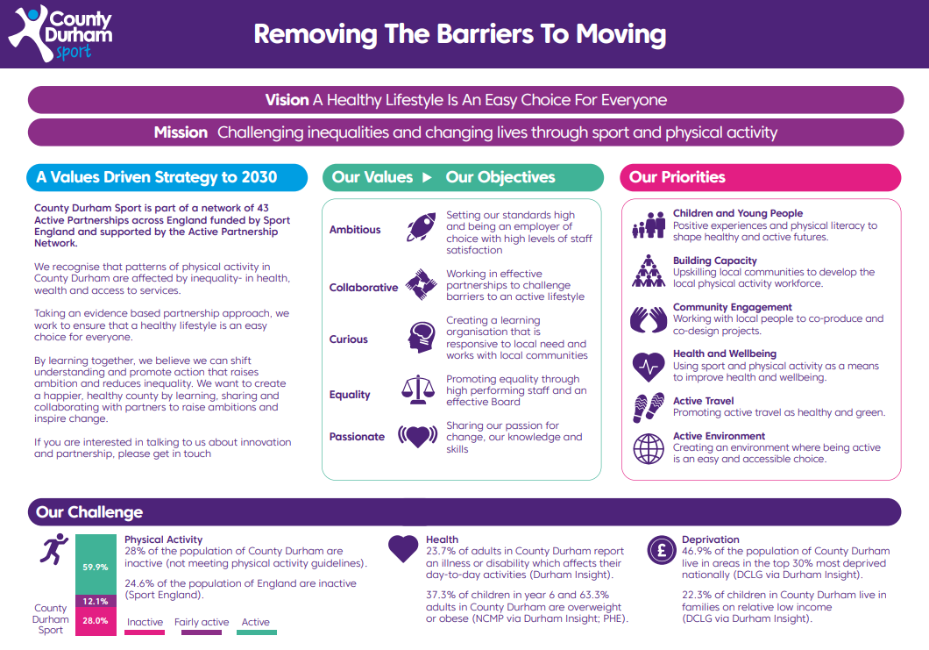

**The Team**

The team is led by a Managing Director and a Senior Management Team which comprises Director of Operations, Office Manager/Company Secretary and Insight Coordinator.

Our work generally is primarily in engagement, partnership and system change and we have staff engaged in communities across the County.

Given the importance of physical literacy and early engagement with physical activity for a healthy lifestyle, one of our main strategic themes focuses on the next generation (led by a Children and Young People Coordinator).

Although a small team, we remain agile and innovative and encourage staff to develop and grow their roles in response to local need. We are also innovative and collaborative in our staffing solutions and have partnered with another local Active Partnership, RISE, on environment and infrastructure issues (including the climate emergency) to fund a joint post.

Finally, we work across the broad theme of health and wellbeing and collaborate regionally, nationally and locally in this area.

More information on the team can be found here: <https://countydurhamsport.com/about-county-durham-sport/#MeetTheTeam>

**Role Profile**

In addition to fulfilling the requirements of the role of Board Member, the Chair plays a lead role in shaping the Board’s development as a strong team, working in a complementary way with the Director’s leadership of their team, to encourage quality discussions and debate.

The structure of the board can be seen below:

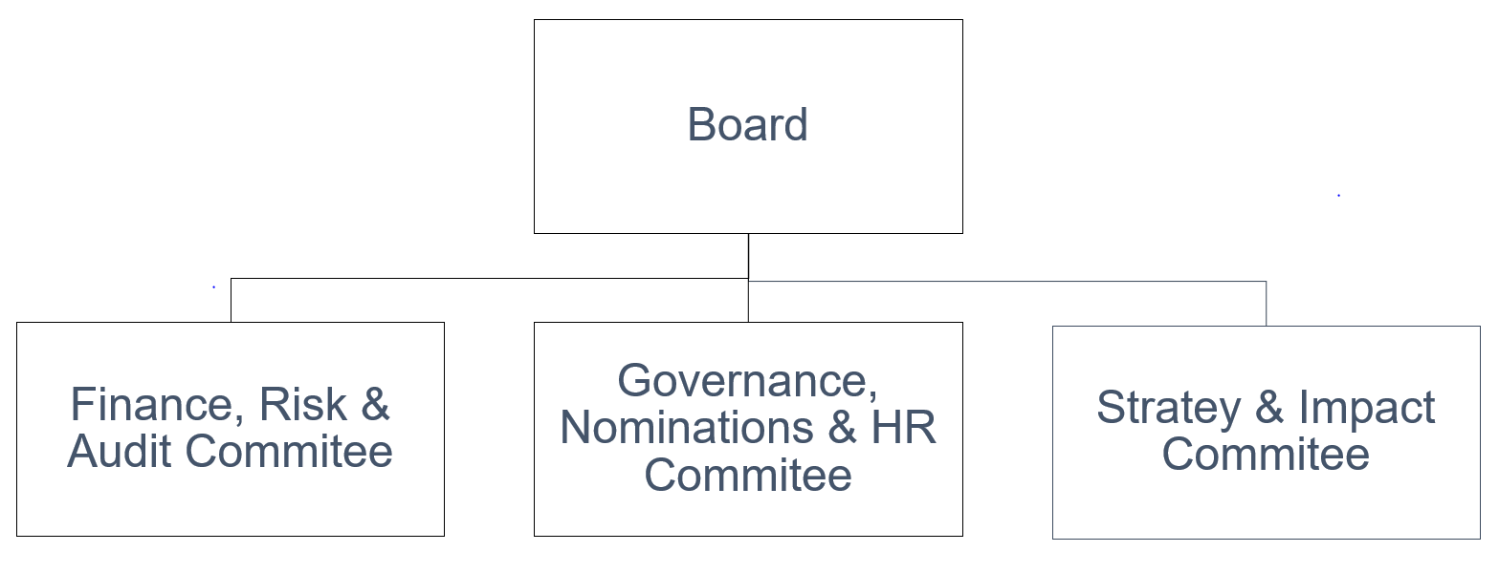

**Core Responsibilities:**

**Strategic direction:**

* Provides strategic leadership to the Board and to the organisation as a whole, working with the Managing Director to ensure that the design of the Board’s work supports the achievement of our strategy.
* Ensures the Board sets County Durham Sport’s vision, mission, values and standards and that its obligations to its stakeholders and others, including any funders, are understood and met.
* The Chair has particular responsibility for providing effective leadership.

**Effective governance:**

* Ensures that the Board delivers its key strategic role and provides effective governance of the organisation, securing its viability and sustainability, and looking to maximise its effectiveness, within the scope of its Terms of Reference.
* Promotes good governance and ensures that County Durham Sport’s affairs are conducted in accordance with generally accepted codes of performance and propriety.
* Contributes to the effective governance of County Durham Sport through membership of any committees or sub-groups.

**Promoting the organisation:**

* Contributes to the promotion and positioning of the organisation with a wide range of external stakeholders.
* The Chair will be the leading advocate for County Durham Sport.

**Ambassadorial role:**

* Acts as an ambassador for County Durham Sport externally and helps build its brand and public image, ensuring an effective local and regional profile in consultation with the Managing Director.
* Represents County Durham Sport with key stakeholders, such as Sport England or other influential decision-makers.
* Attends ad-hoc meetings as required (for example stakeholder meetings) to promote the values and purpose of the organisation.

**Conduct of the Board’s business:**

* Ensures that the business of the Board is conducted efficiently.
* Ensures that Board members are given the opportunity to express their views and their views are sought before important decisions are taken.
* The Chair will manage the Board, set the agenda in conjunction with the Managing Director, chair meetings, lead and facilitate agreement, negotiate and influence agreed outcomes, make statements, confirm decisions and communicate policy.
* Ensures that the Board receives professional advice when it is needed from external sources.
* In the case of urgent business occurring between meetings, takes necessary decisions on behalf of the Board, in accordance with agreed urgency arrangements.

**Working with the Managing Director:**

* Ensures that a constructive working relationship is established with and support provided for the Director.
* Ensures that the Board make proper arrangements to appraise the performance of the Managing Director, to set objectives and to determine the remuneration for this role.
* When necessary (e.g. following a resignation) ensures that any new Managing Director is recruited in a timely and orderly manner in line with the Active Partnership’s employment policies.
* The Chair will ensure the Managing Director is supported and managed.

**Developing the Board team:**

* Considers what the business needs from non-executive skills and take an active role in Board renewal, recruitment and succession planning.
* Ensures that annually the performance of individual Board members, including the Chair, and the Board’s collective performance, is evaluated.
* Establishes a constructive working relationship with Board members.
* The Chair will inspire new Board members and encourage them to use their influence and expertise for the advancement of County Durham Sport.

**Personal Specification**

In addition to fulfilling the requirements of a Board Member, the Chair will demonstrate the following:

**Core Competencies:**

* Leadership: Exceptional leadership skills. Ability to inspire confidence and have a distributed leadership style.
* Strategic thinking: Demonstrates strategic vision, thinking, foresight and insight. Can encourage the Board to think about the level of risk it can entertain to achieve organisational objectives and has ample experience of business planning and review.
* Judgement: Proven track record of providing clear, independent, balanced advice and guidance with the ability to challenge constructively.

**Ability, Skills and Knowledge:**

* Experience of chairing Boards or committees and knowledge of good governance.
* Proven track record of leading an organisation or having high level management experience in the commercial, educational, public or voluntary sector.
* Understanding of the physical activity landscape and the issues currently influencing it.
* A strategic thinker, who can apply creative and imaginative solutions, with good judgement and a commitment to results.
* Skilled at bringing people together to generate a strong team spirit, able to work collaboratively, building consensus and encouraging collegiate decision making.
* Efficient communication skills and flexibility to respond to communication from the Managing Director and Office Manager.
* Financial proficiency and IT literate. Good background in corporate skills.
* Knowledge of the inequalities in County Durham.
* Awareness of systems thinking.

**Personal Attributes:**

* Commitment to County Durham Sport
* Integrity and Credibility
* Willingness to devote the necessary time and effort to the role
* Effective self-management skills
* A strong and clear commitment to equality and diversity

**Terms of Appointment**

**Position:**

Independent Chair of County Durham Sport Board.

**Eligibility:**

The Chair of the Board should have in-depth knowledge and experience of the range of issues faced by County Durham.

As per all Board members, an Independent Chair must meet the eligibility criteria to be ‘independent’. This is defined as being free from any close connection to the organisation and therefore, from the perspective of an objective outsider, they would be viewed as independent.

Examples of this close connection would include:

* They are or have, within the last four years, been actively involved in the organisation’s affairs.
* They are or have within the last four years been an employee of the organisation.
* They have close family ties with any of the organisation’s employees.

**Remuneration:**

This is a voluntary non-salaried position. Travel and other reasonable expenses will be reimbursed.

**Time Commitment:**

We anticipate that the Chair role requires a minimum of 1 day per month commitment on completion of induction. You will be expected to attend meetings of the Board, and to devote adequate time to preparation for evening Board meetings, away days, committees, visiting projects, cross-organisational communication, undertaking training and development events as appropriate, and to attend and participate in reviews linked to individual performance and that of the whole Board.

As a minimum, attendance and preparation should be made for:-

* An induction training event
* A minimum of 4 board meetings annually
* Regular meetings with the Director to monitor and support progress
* Regular communication with the Office Manager/Company Secretary
* Two national meetings
* An appraisal meeting
* Completion of appraisal meetings for individual Board members
* Meetings, as required, with partner organisations

**Terms of Office:**

All appointments and re-appointments will be made in compliance with agreed stipulations regarding terms of office.

The Chair of the Board will normally be appointed for a 3-year period (subject to appraisal and probation).

At the expiry of the period of office the Chair shall be eligible for re-appointment, subject to approval, for two further terms of up to 3 years each.

**End of Term of Appointment/Re-appointment:**

An individual shall cease to be the Chair if they:

* Resign in writing to the Managing Director.
* Are expelled from membership by a resolution carried out by a majority of no less than two thirds of those Board members voting of which due notice has been given. Grounds for expulsion must be specified in the notices calling the meeting and the individual must be given the opportunity to state their case at the meeting. Should they fail to attend with due notice given, the meeting may proceed in their absence.
* Have exceeded their term of appointment and/or re-appointment.
* Failure of probation and appraisal.

**Location:**

Board meetings and events will be held throughout the County Durham region and may be attended virtually or in person depending on circumstances.



